Ghvino Forum 2026

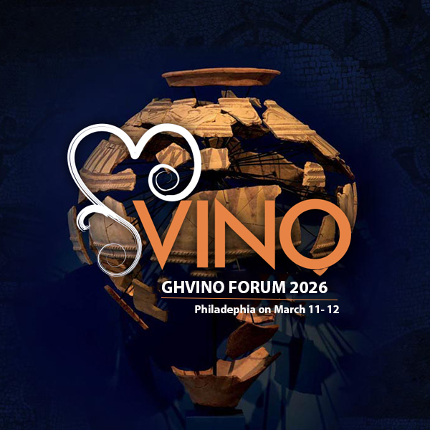

March 12

Widener Lecture Hall, Penn Museum

3260 South St, Philadelphia

www.Ghvinoforum.com

AGENDA

12:45 - 13:00 Registration and Welcome

13:00-13:10

Opening Remarks by:

Mamuka Tsereteli, President, America-Georgia Business Council

Speaker, Penn Museum

13:10 - 13:30 Tribute to Professor Patrick McGovern

13:30 - 14:00 Presentation: Origin of Wine: Case of Georgia

Presented by Professor Steve Batiuk, University of Toronto

14:00 - 14:15 Presentation: Wine as a Part of the Cultural Heritage of Georgia

Presented by Ian Tattersal, American Museum of National History

14:15 - 14:30 Presentation: Digital Strategies for Marketing of Georgian Wines

Presented by Justin Seibert, President, Direct Online Marketing

14:30 - 14:40 Break

14:40 – 15:00 Panel Discussion: Presenting Georgian Wines to American Audience

Dr. Bill Shindler, Founder, Modern Stone Age Kitchen/Author, Archeologist

Dr. Jill Weber, Founder and Owner of Sojourn Phill Restaurant Group/Archeologist

Dr. Arindam Basu, PhD, DipWSET, Owner/Operator of Perfect Pour Experience LLC

Moderated by Noel Brockett, President, Georgian Wine House DC

